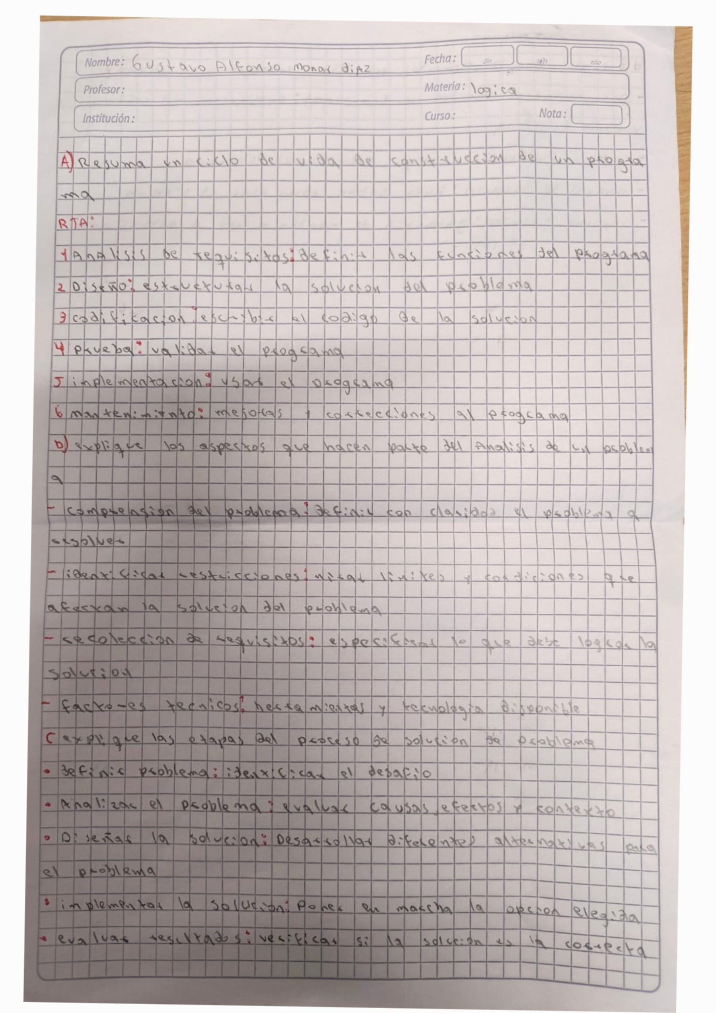

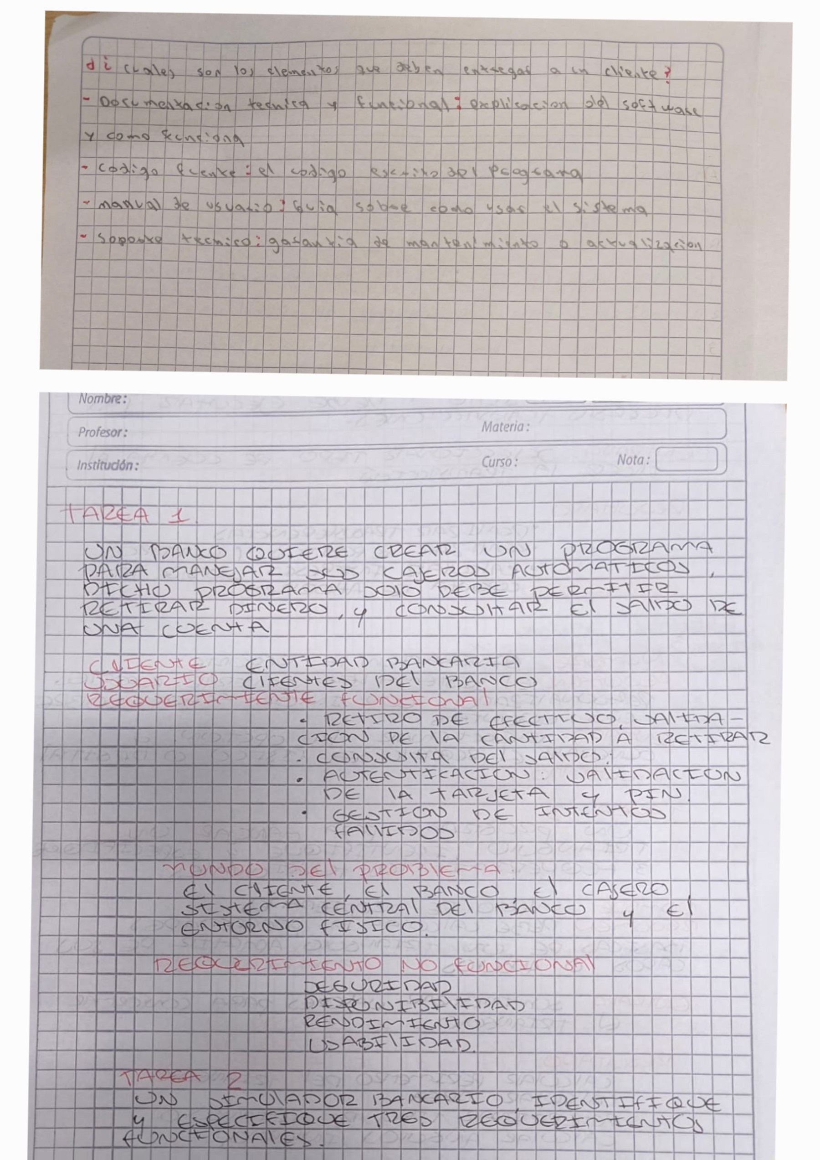

|  |  |  |  |  |  |  |  |  |  |  |  |  |  |  |  |  |  |  |  |  |  |  |  |  |  |  |  |  |  |  |  |  |  |  |  |  |
| --- | --- | --- | --- | --- | --- | --- | --- | --- | --- | --- | --- | --- | --- | --- | --- | --- | --- | --- | --- | --- | --- | --- | --- | --- | --- | --- | --- | --- | --- | --- | --- | --- | --- | --- | --- | --- |
|  | | | |  | | | | | | | | | |  | | | | |  | |  |  | | | | | | | | | | | | |  |  |
| ⅱ | = 1  ' | | | 訂当: :な | | | | | | | | | | 迄当 | | | | | 当 | |  | 当■臨■■目回当 | | | | | | | | | | | | |  |  |
|  | に: | | = | コ | | | | | | | | |  |  | | | | |  | |  | 0 | | | 2当、 | | | | | | | | | | 区  新 |  |
|  |  |  |  |  | 彡塾 | | | | | | | |  |  |  | 鑿 |  |  |  |  |  | ま |  |  | 挈 | 汾 |  |  |  | |  | ロ | 新 | ロ |
|  |  |  | : : | コ | 2潯 | | | | | |  |  |
|  |  | 朝 |  |  |  | | |  |  | ツ |  |  |  |  |  |  |  |  |  |  |
|  | 。。 | ミ | 雲 |  |  |  |  |  |  |  |  |  |  |  |  |  |  | 0 |  | ロ | 驫 | ロ |  | 立 | 回 |  | ■ |
|  |  |  |  |  |  |  |  |  |  |  |  |  |  |  |  |  |  |  |  |  |  |  |
|  |  |  |  | を | , |  |  |  | 貰 | : |  |  |  |  |  | 霻 |  |  |  |  | g |  | 当 |  |  |  |  | ミ | 報 |  |  |  |  | 当 |  |  |
|  |  |  |  |  | ー | ー・・ | ~ |  | |  |  |  |  |  |  |  | |  | 逶 |  |  |  | ム |  |  |  | 新  際 |  | ロ | 苞  住 | 当 | 当  ロ当 | 00  ■  0 菱 |  |  |
|  |  |  |  |  |  |  |  |  | ; | 縁 | ロ ■ ロ 0 | 0  ■ |
|  |  |  |  |  |  |  | . |  |  | 」 |  |  |  |  |  |  |  |  |  | 建 | 奎 |
|  |  |  |  |  |  |  |  |  | : | は |  |  |  |  |  |  |  | 当 |  |  | き | 、 | 譏 | |  |
|  |  |  |  |  |  |  |  | ・: |  |  | Z |  |  |  |  | 当 |  | 靉 |  |  |  | 巡 | 置 | |  | 当 |  | ■ | 置 | 当 |  | 直 |
|  | |  |  |  |  | |  | 寰 | | : |  |  |  |  | ! |  |  | さ | を |  |  |  |  |  |  | 0 | ロ | ロ | 0 | ロ |  | ロ |  | 0 |
|  | |  |  |  |  | |  |  |  |  |  |  |  |  |  |  |  |  |  |  |  |  |  |  |  |  |  |  |  |  |  |  |  |  |  |  |
|  | |  |  |  |  | |  |  |  |  |  |  |  |  |  |  |  |  |  |  |  |  |  |  |  |  |  |  |  |  |  |  |  |  |  |  |
|  | | | | | | | | | | | | | | | | | | | | | | | | | | | | | | | | | | | | |

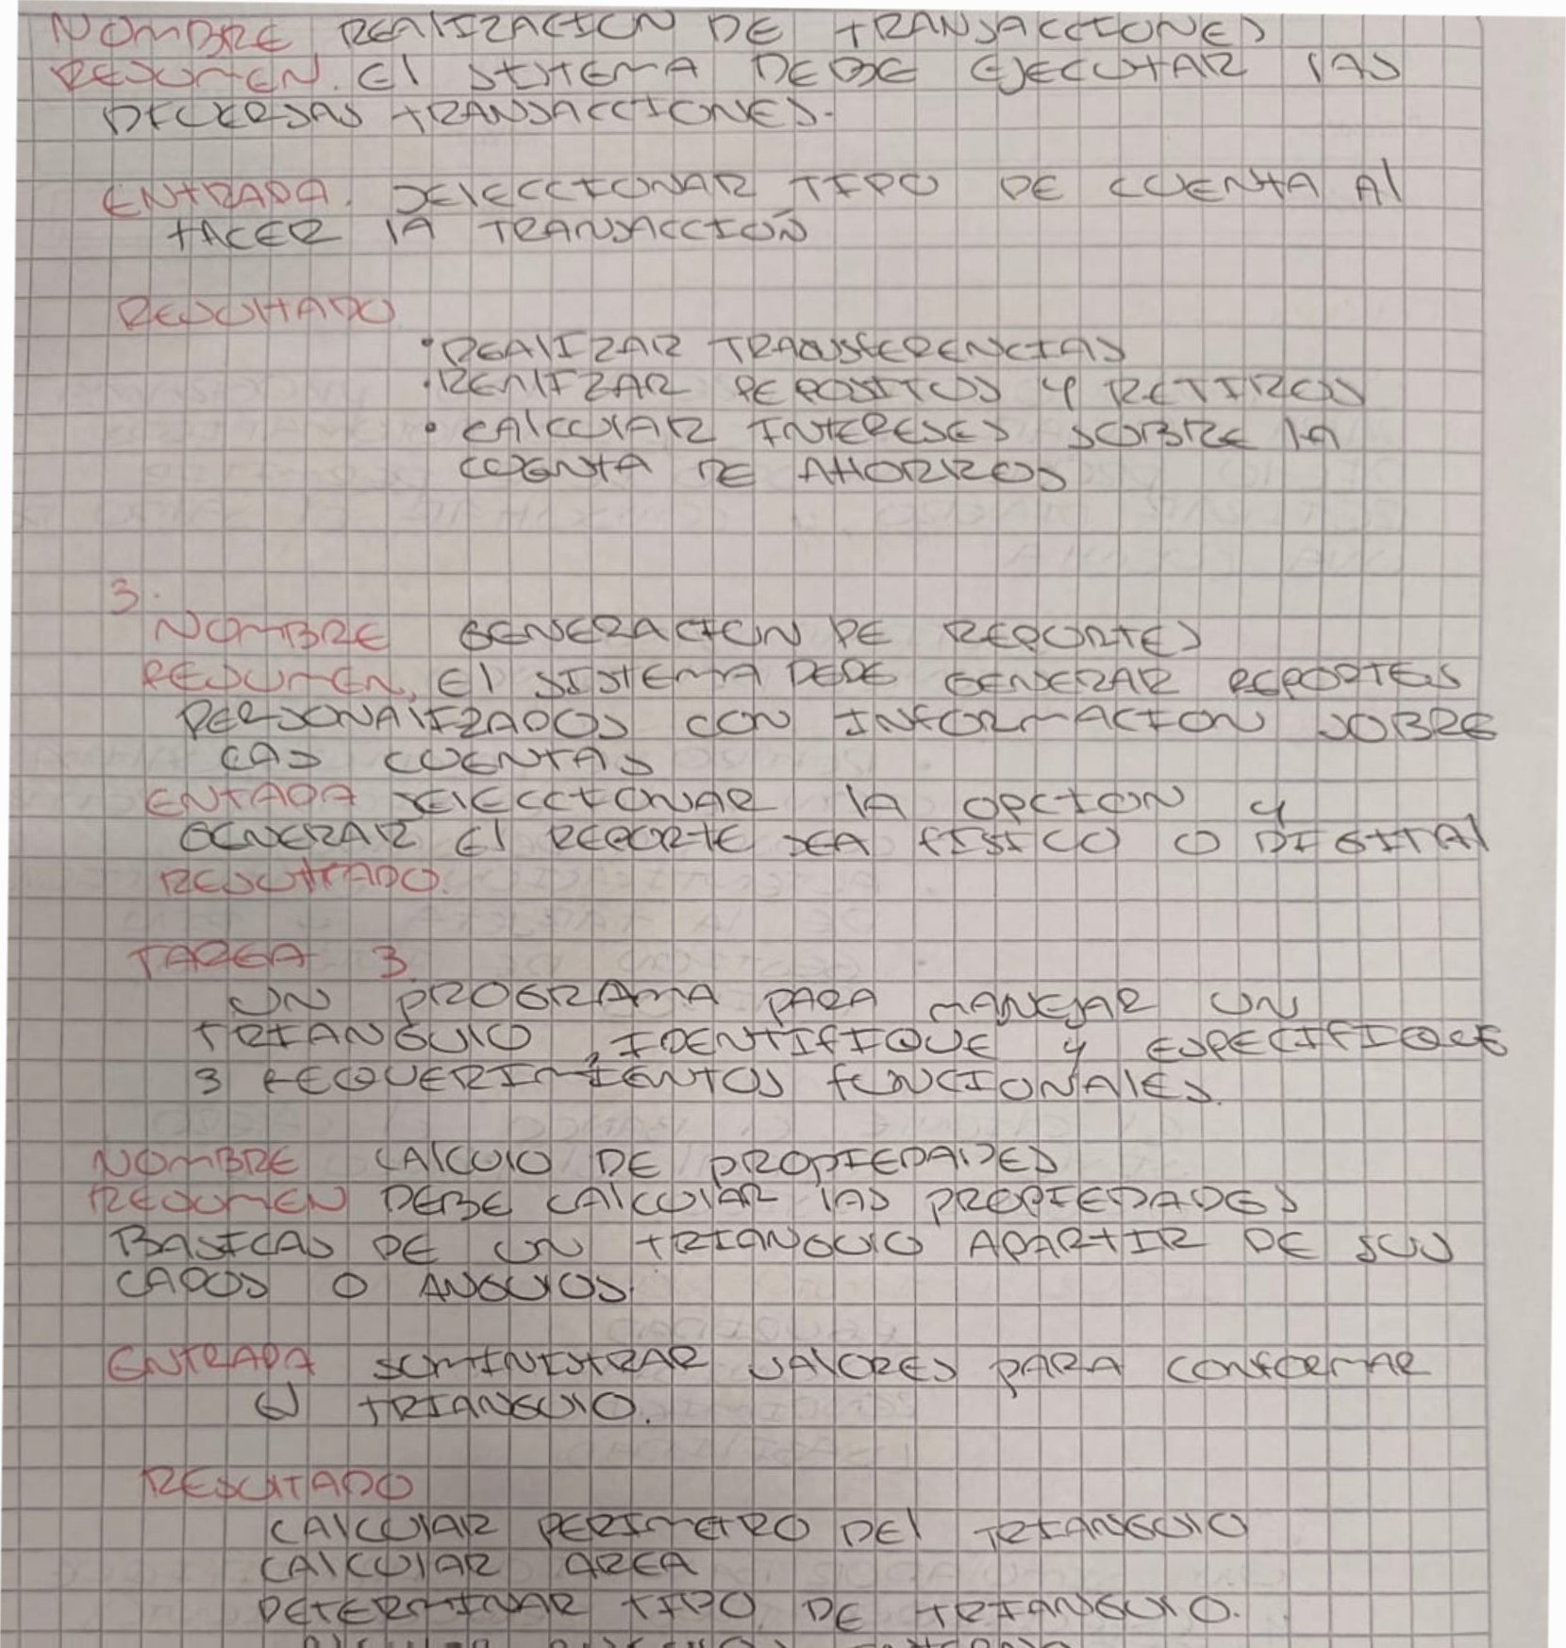ーー

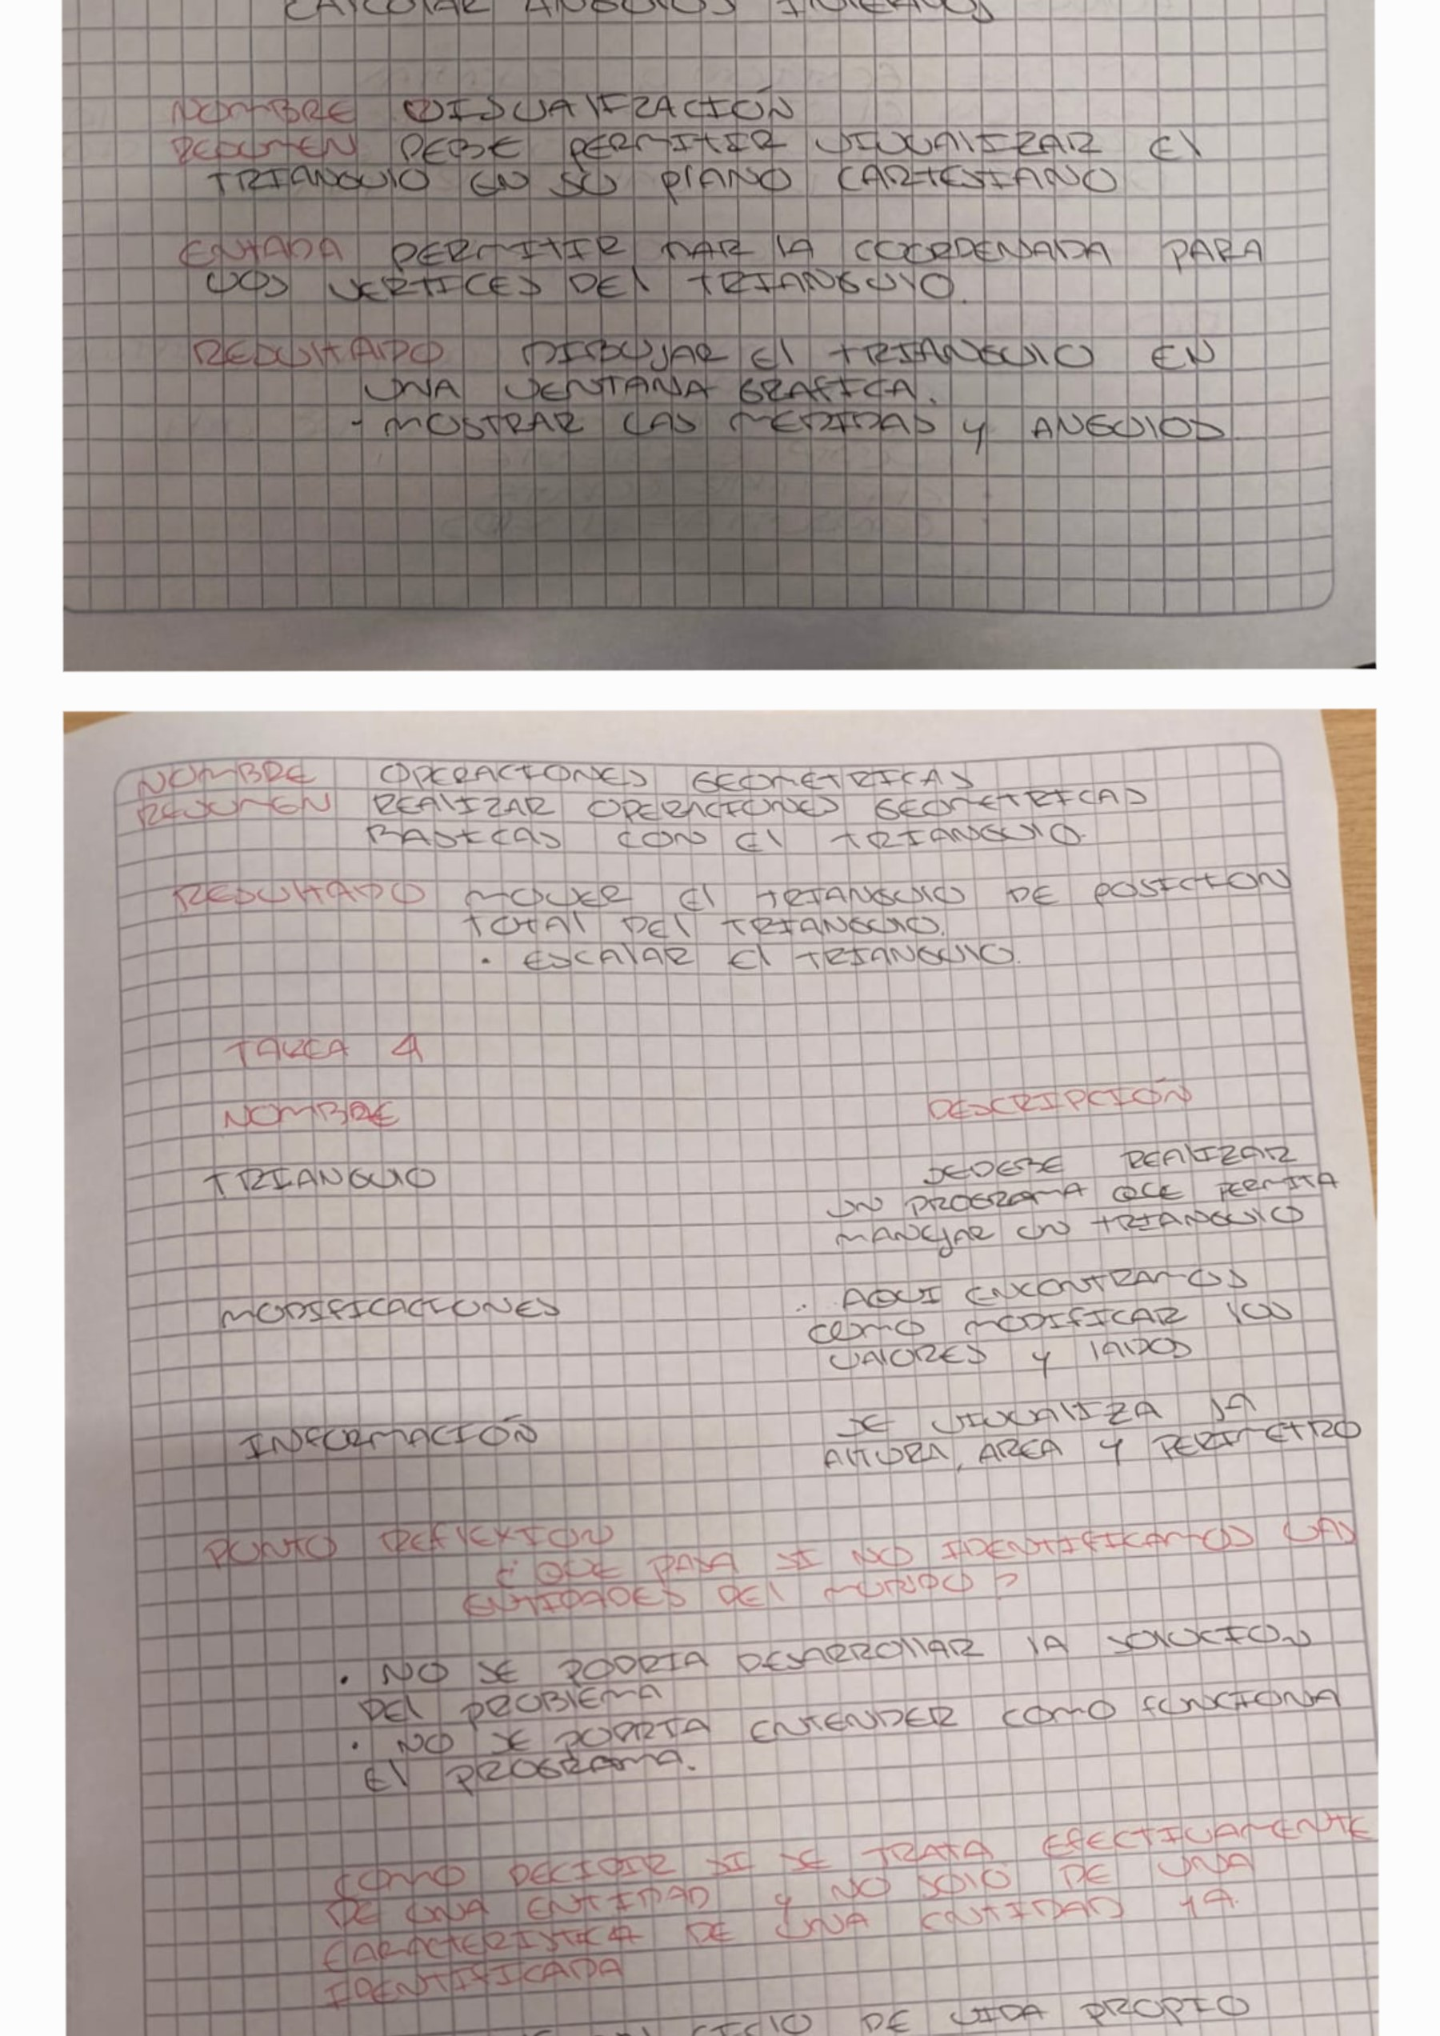

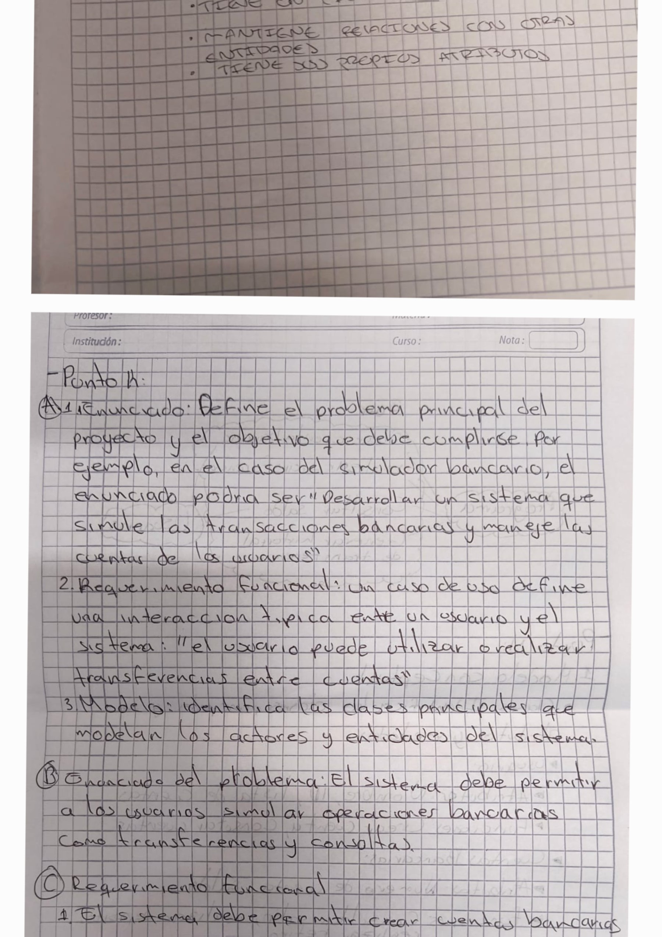

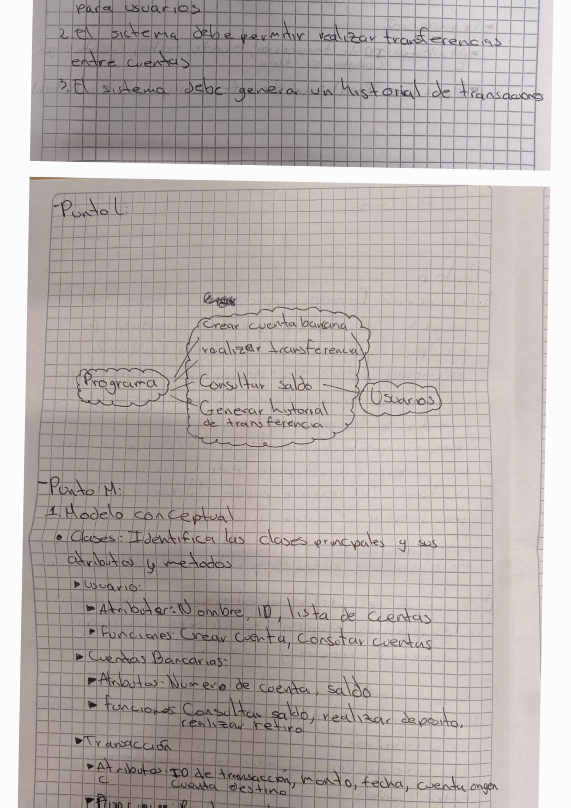





# 20

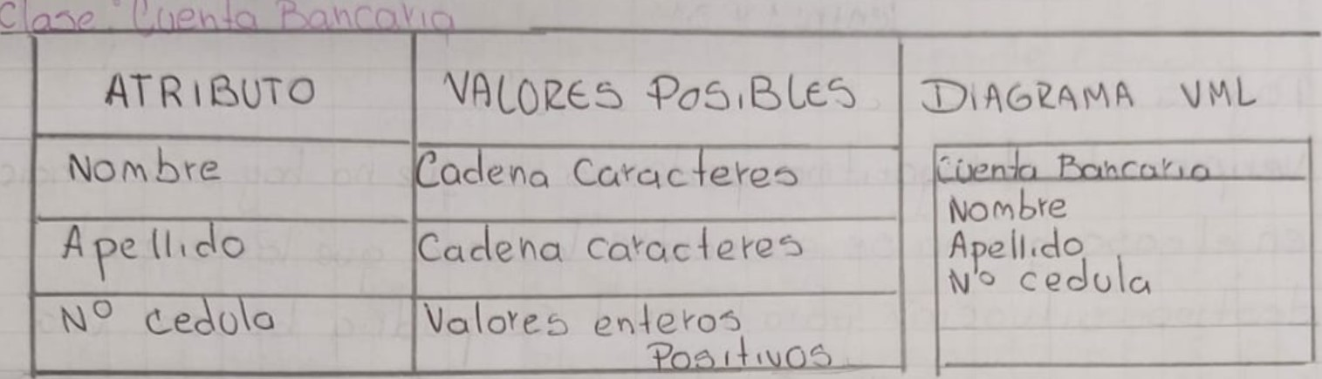

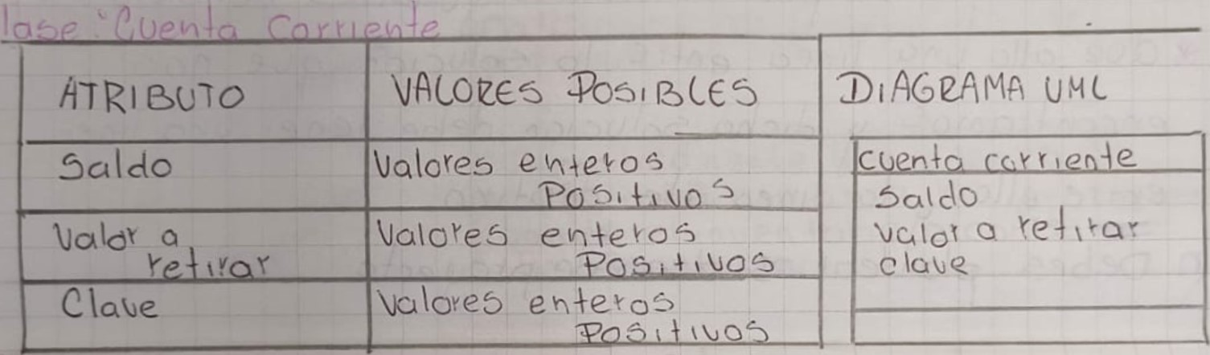

|  |  |  |  |  |  |  |  |  |  |
| --- | --- | --- | --- | --- | --- | --- | --- | --- | --- |
|  |  | VACCzes BCQ6 | | | DiACùAMq u MC | | | | |
| Const |  | | |  | | | |  |
|  | |  | | |
|  | \OVe6  0 | | |
|  | alores etoÀŸe | |  |
|  | | |
| R I B(SÑC) | | |  | | |  | | | | |
| De A o | | | enAe?06 | | |  | |  | | |
| De | | |
|  | | |  | | |
|  | | | o\oves en exc» c; | | |
|  | | |
|  | | |  | | |  | | |

|  |  |  |  |  |  |  |  |  |  |  |  |  |  |  |  |  |  |  |
| --- | --- | --- | --- | --- | --- | --- | --- | --- | --- | --- | --- | --- | --- | --- | --- | --- | --- | --- |
| |  |  |  |  |  |  |  |  |  |  |  |  |  |  | | --- | --- | --- | --- | --- | --- | --- | --- | --- | --- | --- | --- | --- | --- | | |  |  |  | | --- | --- | --- | |  |  |  | | | Ко |  | |  | соде По (Ае | |  |  | |  |  | | |  |   сспскс»с- | | | |  |
|  |  | КОспЬее |  |
|  |  |
|  | ptoducA0b (enAic.\do , 50kdQ помКуе, сос\яо: |
|  | de pfodoc\03 |
| 2 |  | Hodot6 Ме- |
|  | tl е Азо е5 aclSY06 Де мадеуо ка 5egcn 106 те (5 $ еес\оо еп е |
|  | 00405 бе у  Де Коз |
|  | *acAuYQ5 ел 0' ос\ое» соеуео е\есА ротсо. ос 4омо4ясомелАе |  |
|  | | | |

